**Ideation Phase**

**Define the Problem Statements**

|  |  |
| --- | --- |
| Date | 10 April 2025 |
| Team ID | SWTID1743172790 |
| Project Name | Social Media Web App |
| Maximum Marks | 3 Marks |

**Customer Problem Statement Template:**

**Problem 1:** How can we design and implement a robust social media web application using the MERN stack that enables real-time communication (messaging, notifications, story updates, etc.) across multiple users and devices, while maintaining high scalability, performance, and minimal latency?

**Problem 2:** How can we ensure the security, privacy, and data protection of users in a MERN stack-based social media application, while delivering an intuitive, seamless, and engaging user experience?

**Example:**

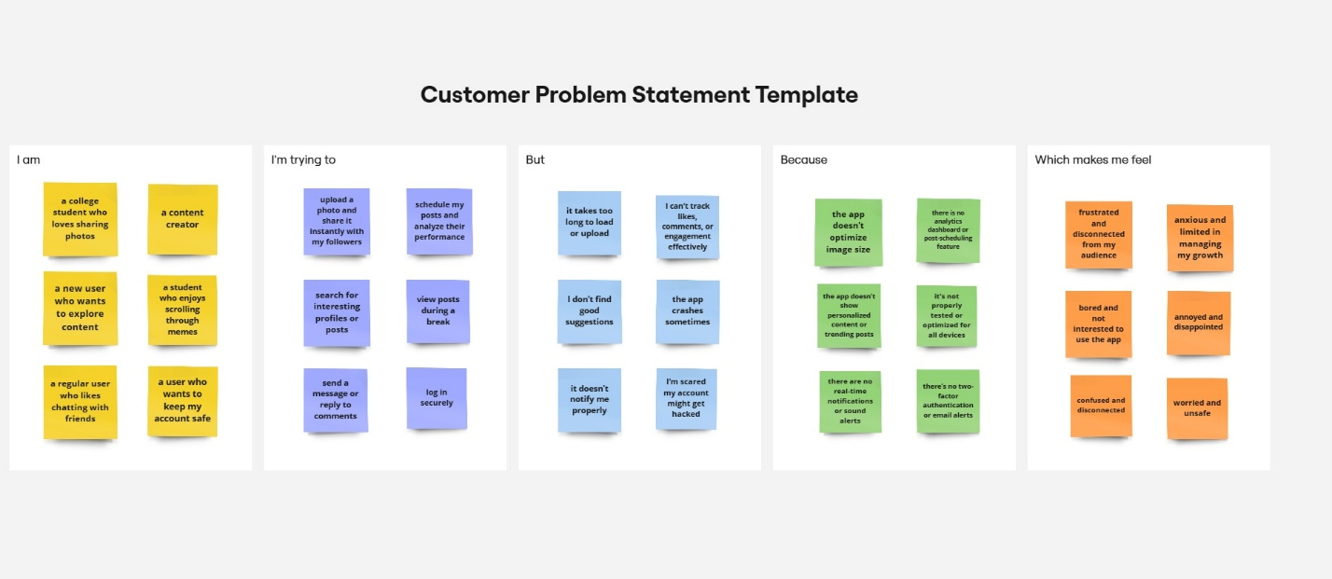

|  |  |  |  |  |  |
| --- | --- | --- | --- | --- | --- |
| **Problem Statement (PS)** | **I am (Customer)** | **I’m trying to** | **But** | **Because** | **Which makes me feel** |
| PS-1 | a college student who loves sharing photos | upload a photo and share it | it takes too long to load or upload | the app doesn’t optimize image size and lacks proper backend caching | frustrated and disconnected from my audience |
| PS-2 | a content creator who relies on social media to grow my personal brand | schedule my posts and analyze their performance | I can't track likes, comments, or engagement effectively | there is no analytics dashboard or post-scheduling feature in the app | anxious and limited in managing my growth |
| PS-3 | a new user who wants to explore content | search for interesting profiles or posts | I don’t find good suggestions | the app doesn’t show personalized content or trending posts | bored and not interested to use the app |
| PS-4 | a student who enjoys scrolling through memes | view posts during a break | the app crashes sometimes | it's not properly tested or optimized for all devices | annoyed and disappointed |
| PS-5 | a regular user who likes chatting with friends | send a message or reply to comments | it doesn’t notify me properly | there are no real-time notifications or sound alerts | confused and disconnected |
| PS-6 | a user who wants to keep my account safe | log in securely | I’m scared my account might get hacked | there’s no two-factor authentication or email alerts | worried and unsafe |